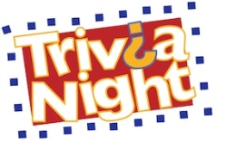 TRIVIA NIGHT 2014
ACAF is hosting its 2nd Annual Trivia Night on Friday, October 24, 2014 to benefit the Allegany County Area Foundation Dollars for Scholars Program. This event will be held at the Cuba, NY VFW. Get your friends, family and co-workers together! Our check-in will begin at 5:30 and the contest gets underway at 6:30 (Age: 21+). Each team may have up to six members. We will play six to eight rounds. There will be a Championship Round and Tie Breaker if needed. The cost is $180.00 per team. This includes: food, soft drinks, music, fun and prizes for the rounds and overall winner. Payment can be made on our web site using our donation page (select the "Trivia Night Entry Fee" on the pull-down menu).
Trivia Team Name:___________________________
Members Name: email address/phone
1.__________________________________________________________________
2.__________________________________________________________________
3.__________________________________________________________________
4.__________________________________________________________________
5.__________________________________________________________________
6.__________________________________________________________________
Mail this completed form to: Allegany County Area Foundation
6087 State Route 19N
Belmont, NY 14813
Make your check payable to: The Allegany County Area Foundation (or you may pay online as indicated above). Payment must be received by October 23rd.
For more information contact: Denis Dahlgren, Executive Director – 585-808-8444
or e-mail: director@alleganycountyareafoundation.org.

